Week 3-Day 2

Class Assignment 1

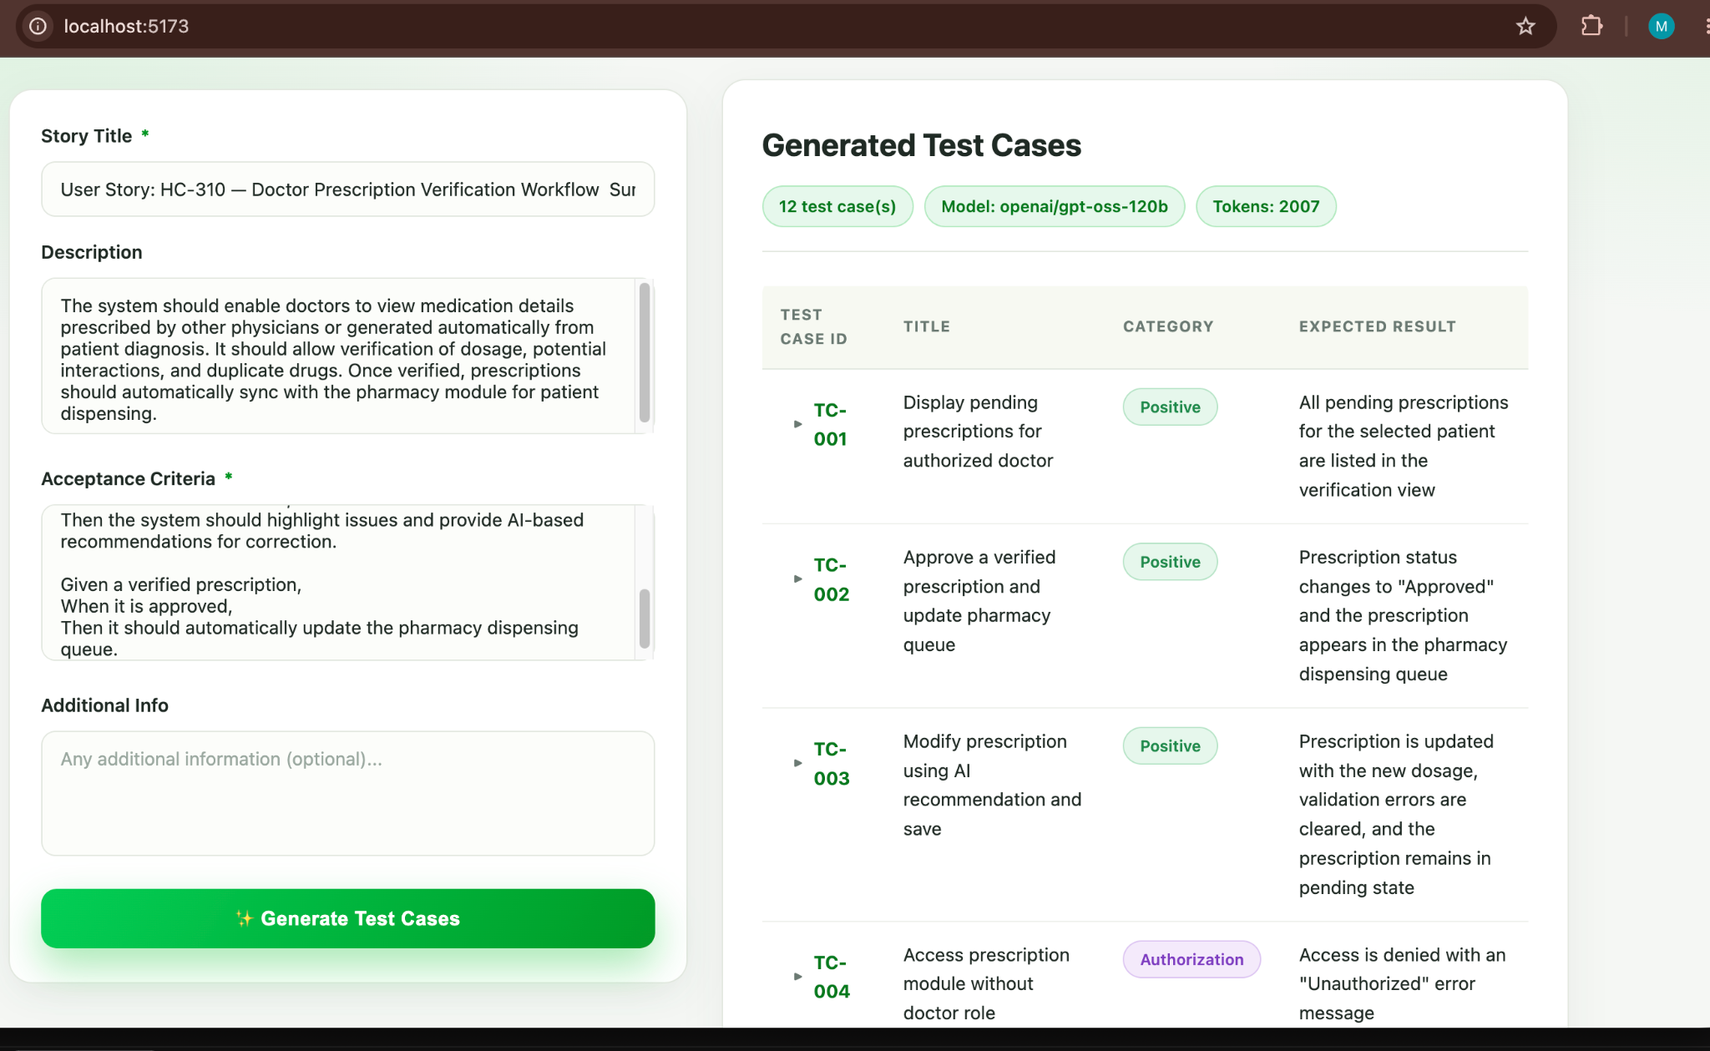

USer story2-
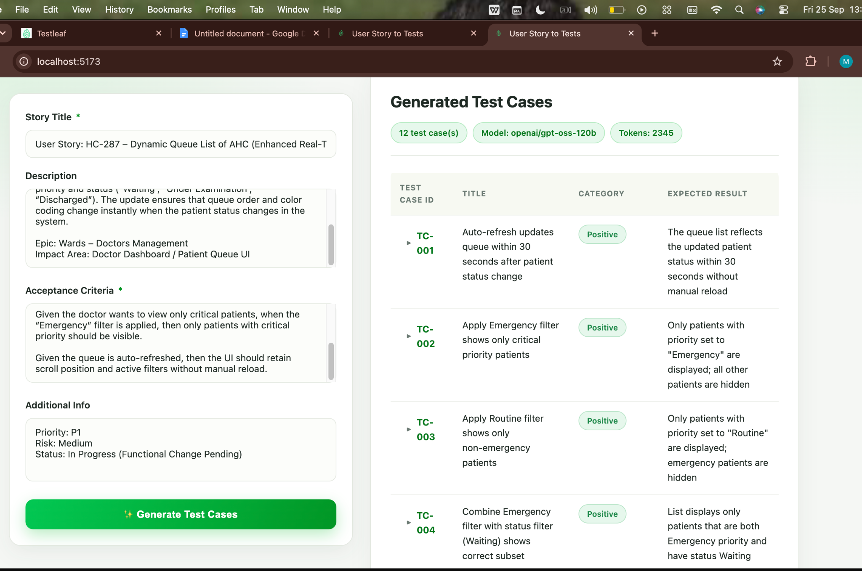

Test Case ID | Title | Category | Expected Result
▶TC-001 | Auto-refresh updates queue within 30 seconds after patient status change | Positive | The queue list reflects the updated patient status within 30 seconds without manual reload
▶TC-002 | Apply Emergency filter shows only critical priority patients | Positive | Only patients with priority set to "Emergency" are displayed; all other patients are hidden
▶TC-003 | Apply Routine filter shows only non‑emergency patients | Positive | Only patients with priority set to "Routine" are displayed; emergency patients are hidden
▶TC-004 | Combine Emergency filter with status filter (Waiting) shows correct subset | Positive | List displays only patients that are both Emergency priority and have status Waiting
▶TC-005 | Queue remains empty and auto‑refresh does not produce errors when no patients exist | Edge | Queue list stays empty; no error messages appear; auto‑refresh completes silently
▶TC-006 | All patients are emergency; applying Emergency filter shows full list | Edge | All 10 patients are displayed; filter does not hide any rows
▶TC-007 | Applying an invalid filter value does not crash the UI | Negative | UI shows a friendly message or ignores the invalid filter; no crash or unhandled exception occurs
▶TC-008 | System delay beyond 30 seconds does not cause premature UI update | Negative | Queue list does not update before the 45‑second delay; after delay, it updates within the next 30‑second refresh window
▶TC-009 | Unauthorized user cannot access the dynamic queue list | Authorization | Access is denied with an appropriate authorization error message; queue UI is not displayed
▶TC-010 | Scroll position is retained after auto‑refresh | Non-Functional | After refresh, the view remains at the same scroll offset; the previously visible patient row stays in view
▶TC-011 | Auto‑refresh completes within acceptable performance threshold | Non-Functional | Refresh operation completes in 2 seconds or less, measured from trigger to UI update
▶TC-012 | Active filters persist after multiple auto‑refresh cycles | Positive | Filters remain active throughout all refreshes; displayed patient list continues to match filter criteria

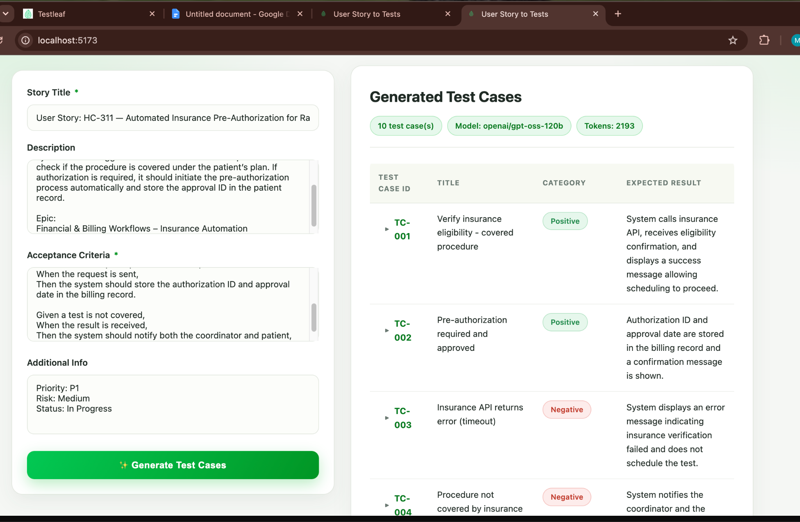

Test Case ID | Title | Category | Expected Result
▶TC-001 | Verify insurance eligibility - covered procedure | Positive | System calls insurance API, receives eligibility confirmation, and displays a success message allowing scheduling to proceed.
▶TC-002 | Pre‑authorization required and approved | Positive | Authorization ID and approval date are stored in the billing record and a confirmation message is shown.
▶TC-003 | Insurance API returns error (timeout) | Negative | System displays an error message indicating insurance verification failed and does not schedule the test.
▶TC-004 | Procedure not covered by insurance | Negative | System notifies the coordinator and the patient that the test is not covered and presents alternative payment options.
▶TC-005 | Patient has multiple insurance policies – primary selected | Edge | System uses the primary policy for eligibility check, receives covered response, and proceeds with scheduling.
▶TC-006 | Invalid patient identifier | Negative | System shows a validation error stating the patient record cannot be found and prevents further action.
▶TC-007 | User without scheduling permission attempts to schedule test | Authorization | System denies the action, displays an authorization error, and does not call the insurance API.
▶TC-008 | Insurance verification response time within SLA | Non-Functional | Insurance API response is received and processed in ≤ 2 seconds, and the scheduling UI updates promptly.
▶TC-009 | Secure transmission of insurance data | Non-Functional | All data sent to the insurance provider is encrypted via HTTPS (TLS 1.2 or higher) and no plain‑text data is logged.
▶TC-010 | System handles unexpected insurance response format | Edge | System logs the parsing error, shows a generic failure message to the coordinator, and does not schedule the test.

Class Assignment 2

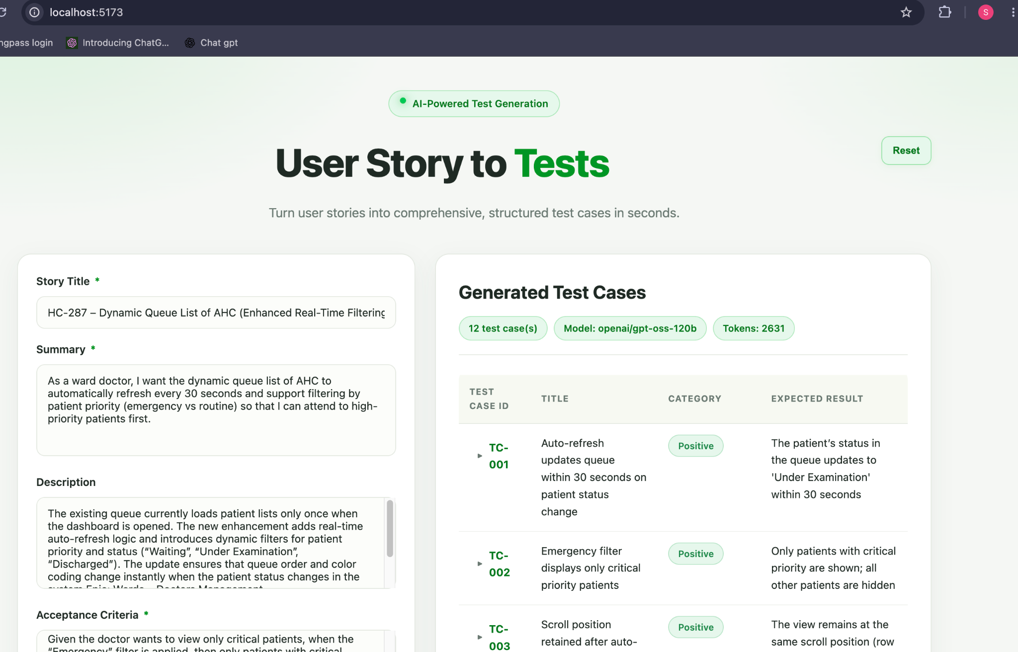

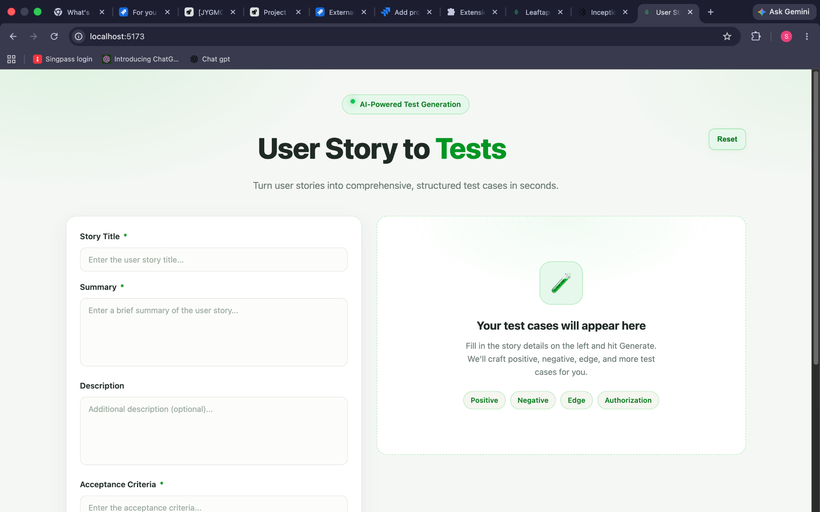

Home Assignment:

